Ideation Phase
Brainstorm & Idea Prioritization

Date | 31 January 2026
Team ID | SWTID-2026-5878
Project Name | Automating Data Import and Relationship Mapping using Import Sets and Dot Walking
Maximum Marks | 4 Marks

Brainstorm & Idea Prioritization Template:
1. Problem Statement Automate employee data imports and display the manager's email on Incidents without manual entry.
2. Brainstorming
- Import: Scheduled Import Sets vs. REST API
- Display: Form Layout Dot-Walking vs. Client Scripts?
3. Prioritization
Selected Approach: Import Sets + Dot-Walking (Highest score for performance and ease of use).
Step-1: Team Gathering, Collaboration and Select the Problem Statement
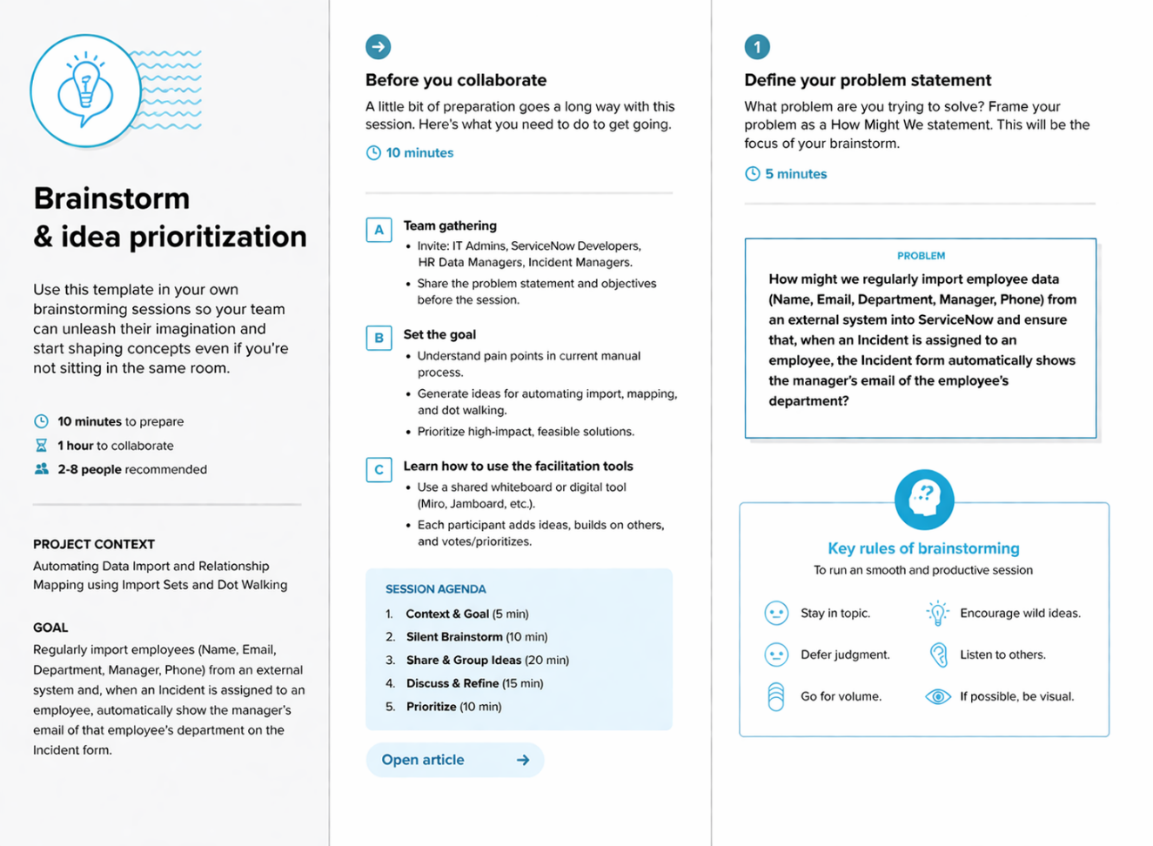

Step-2: Brainstorm, Idea Listing and Grouping
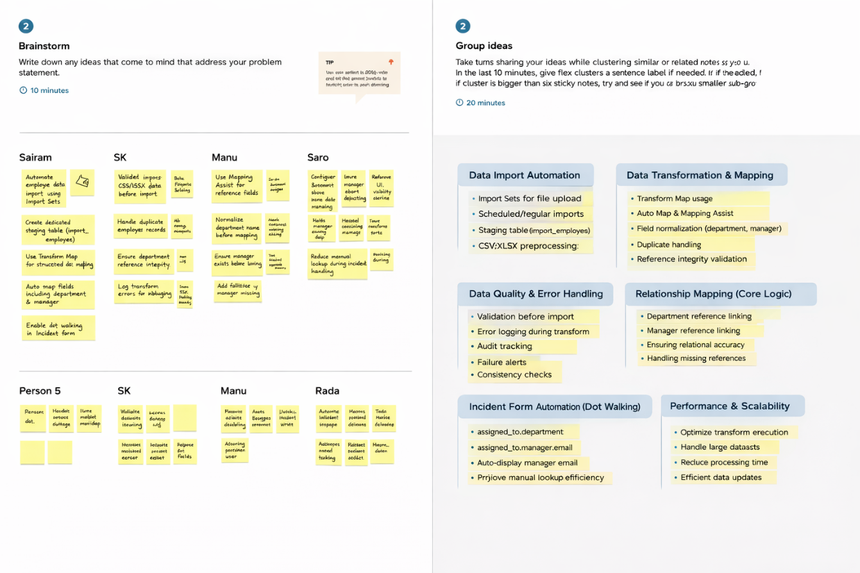

Step-3: Idea Prioritization
